

**ENGLISH PROFICIENCY TEST (EPT)**

**PRACTICE SET 2**

**SECTION 3**

**READING COMPREHENSION**

**Time: 55 minutes**

**Now set your clock for 55 minutes.**

This section is designed to measure your ability to read and understand short passages similar in topic and style to those that students are likely to encounter in universities and colleges. This section contains reading passages and questions about the passages.

Directions: In this section you will read several passages. Each one is followed by a number of questions about it. You are to choose the one best answer, (A), (B), (C), or (0), to each question. Answer all questions about the information in a passage on the basis of what is stated or implied in that passage.

**Read the following passage:**

John Quincy Adams, who served as the sixth president of the United States from 1825 to 1829, is today recognized for his masterful statesmanship and diplomacy. He dedicated his life to public service, both in the presidency and in the various other political offices that he held. Throughout his political career, he demonstrated his unswerving belief in freedom of speech, the antislavery cause, and the right of Americans to be free from European and Asian domination.

Line 5

**Example I**

To what did John Quincy Adams devote his life?

(A) Improving his personal life

(B) Serving the public

(C) Increasing his fortune

(D) Working on his private business

According to the passage, **John Quincy Adams "dedicated his life to public service."** Therefore, you should choose answer **(B).**

**Example II**

In line 4, the word "unswerving" is closest in meaning to

(A) moveable

(B) insignificant

(C) unchanging

(D) diplomatic

The passage states that John Quincy Adams demonstrated his unswerving belief "throughout his career." This implies that the belief did not change. Therefore, you should choose answer (C). The sentence should read, **"When did the doctor attend the conference?"** Therefore, you should choose answer **(B).**

**3 – 3 – 3 – 3 – 3 – 3 – 3 – 3 – 3**

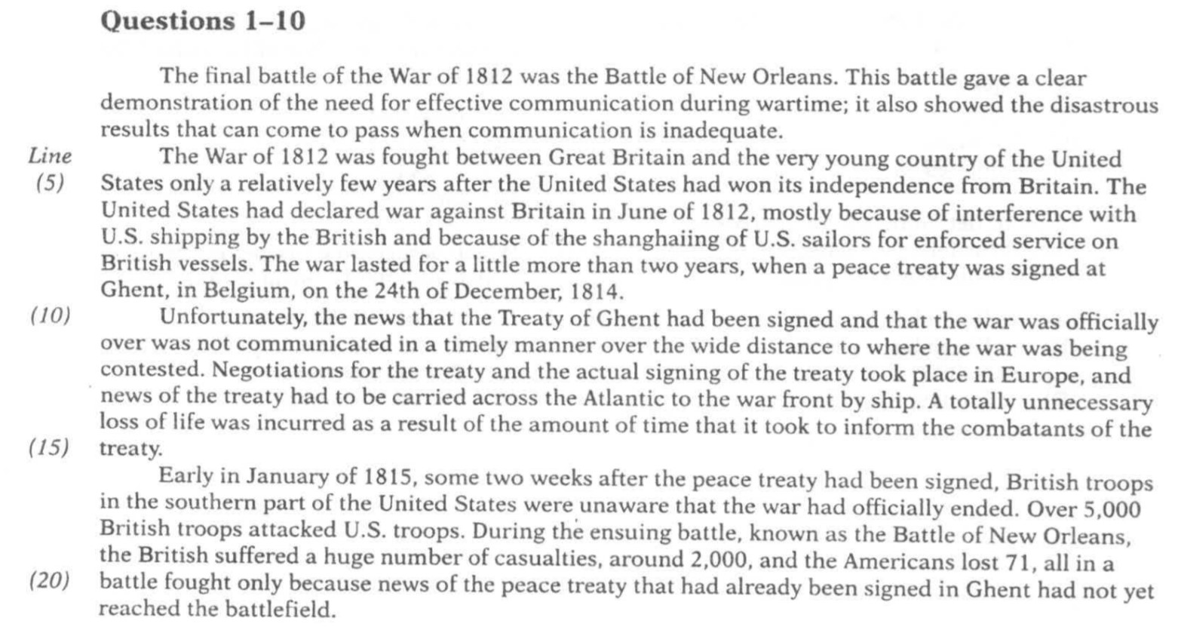

1. The main idea of this passage is that
2. the War of Independence was unnecessary
3. the War of 1812 was unnecessary
4. the Treaty of Ghent was unnecessary
5. the Battle of New Orleans was unnecessary
6. The pronoun "it" in line 2 refers to
7. battle
8. demonstration
9. communication
10. wartime
11. The expression "come to pass" in line 3 could best be replaced by
    1. happen
    2. overthrow
    3. self-destruct
    4. circumvent
12. According to the passage, when did the United States win its independence from Britain?
    1. Shortly before the War of 1812
    2. During the War of 1812
    3. Just after the War of 1812
    4. Long after the War of 1812
13. According to the passage, some U.S. sailors were
    1. taken forcibly to Shanghai
    2. made to go to Ghent
    3. forced to work on British ships
    4. responsible for causing the War of 1812
14. It is NOT stated in the passage that Ghent was
    1. where negotiations took place
    2. the site of the final battle
    3. where the treaty was signed
    4. far from the battlefield
15. The word "contested" in line 12 is closest in meaning to
    1. played
    2. fought
    3. discussed
    4. examined
16. It can be determined from the passage that, of the following dates, the Battle of New Orleans was most probably fought
    1. on December 10, 1814
    2. on December 24, 1814
    3. on January 1,1815
    4. on January 8, 1815
17. Where in the passage does the author indicate when the War of 1812 officially ended?
    1. Lines 1-3
    2. Lines 4-5
    3. Lines 8-9
    4. Lines 10-12
18. Which paragraph describes the battle that took place after the signing of the treaty?
    1. The first paragraph
    2. The second paragraph
    3. The third paragraph
    4. The last paragraph

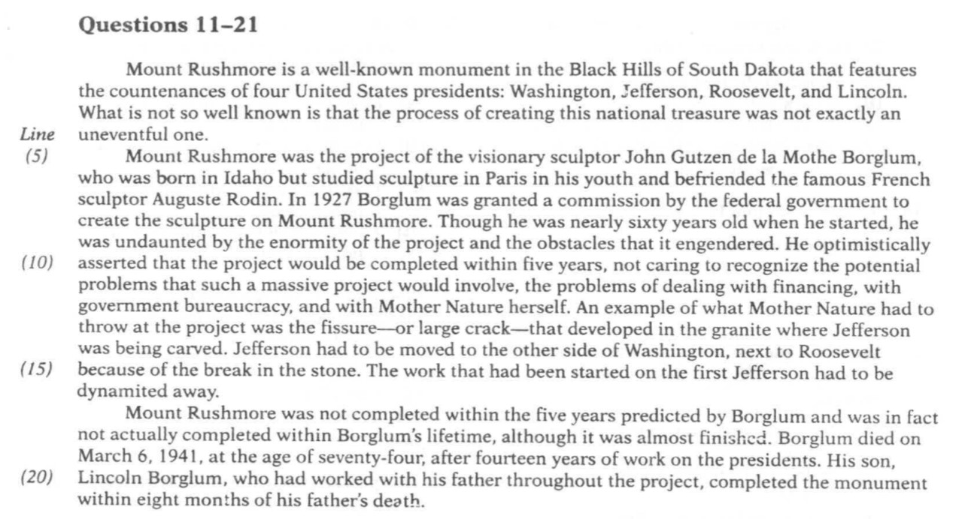

1. Which of the following best expresses the main idea of the passage?
   1. Mount Rushmore was a huge project filled with numerous obstacles.
   2. Mount Rushmore is a famous American monument.
   3. Mount Rushmore has sculptures of four United States presidents on it.
   4. John Gutzen de la Mothe Borglum created Mount Rushmore.
2. Which of the following best describes the relationship between Borglum and Rodin in Borglum's early years?
   1. Borglum studied about Rodin in Paris.
   2. Borglum was far more famous than Rodin as a sculptor.
   3. Borglum and Rodin were born and raised in the same place.
   4. Borglum and Rodin were friends.
3. The word "nearly" in line 8 could best be replaced by which of the following.
   1. Over
   2. Closely
   3. Almost
   4. Barely
4. Which of the following is NOT true about Borglum?
   1. He began Mount Rushmore around the age of sixty.
   2. He predicted that Mount Rushmore would be finished around 1932.
   3. Mount Rushmore was finished when Borglum predicted it would be.
   4. Borglum worked on Mount Rushmore for more than a decade.
5. It can be inferred from the passage that Borglum was someone who
   1. expected the best to happen
   2. set realistic goals
   3. never tried anything too challenging
   4. was always afraid that bad things were going to happen
6. A "fissure" in line 13 is a
   1. discoloration
   2. break
   3. unevenness
   4. softness
7. Why does the author mention the fact that the carving of Thomas Jefferson was moved?
   1. It shows what a perfectionist Borglum was.
   2. It demonstrates Borglum's artistic style.
   3. It gives insight into Jefferson's character.
   4. It is an example of a problem caused by nature.
8. The pronoun "it" in line 18 refers to which of the following?
   1. The first Jefferson
   2. Mount Rushmore
   3. Borglum's lifetime
   4. Fourteen years of work
9. Which of the following is closest in meaning to the expression "within eight months of his father’s death" in line 21?
   1. More than eight months before his father's death
   2. Less than eight months before his father's death
   3. Less than eight months after his father's death
   4. More than eight months after his father's death
10. Where in the passage does the author mention when the Mount Rushmore project got started?
    1. Lines 1-4
    2. Lines 7-8
    3. Lines9-12
    4. Lines 17-18
11. This passage would most likely be assigned reading in a course on
    1. art history
    2. geography
    3. management
    4. government

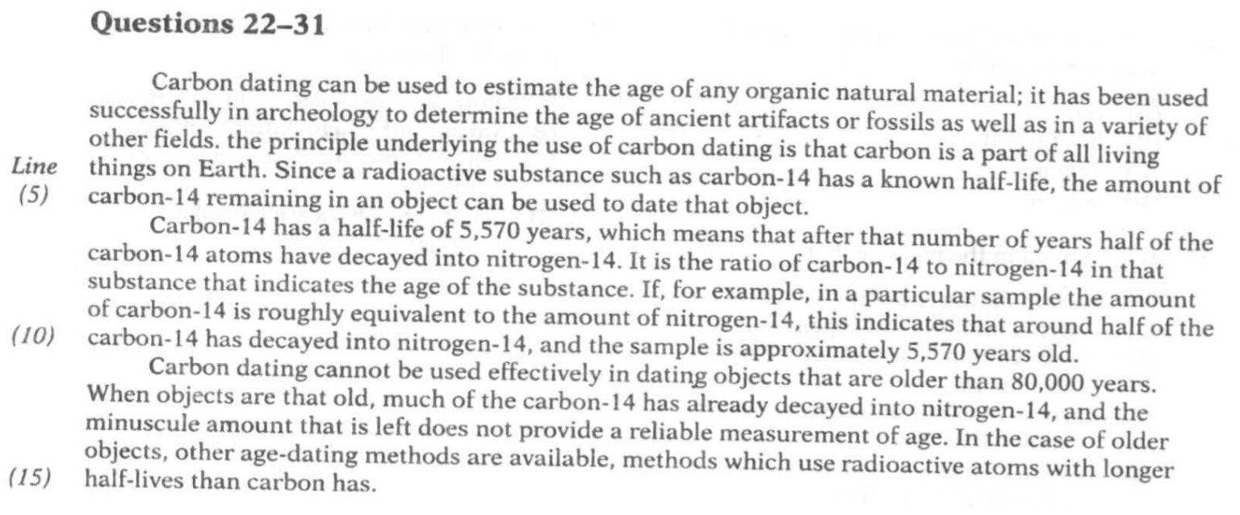

1. This passage is mainly about
   1. the differences between carbon-14 and nitrogen-14
   2. one method of dating old objects
   3. archeology and the study of ancient artifacts
   4. various uses for carbon

1. The word "estimate" in line 1 is closest in meaning to
   1. understand
   2. hide
   3. rate
   4. approximate
2. The pronoun "it" in line 1 refers to
   1. carbon dating
   2. the age
   3. any organic natural material
   4. archeology
3. Which of the following is NOT true about carbon-14?
   1. It is radioactive.
   2. Its half-life is more than 5,000 years.
   3. It and nitrogen always exist in equal amounts in any substance.
   4. It can decay into nitrogen-14.
4. The word "underlying" in line 3 could best be replaced by
   1. below
   2. requiring
   3. being studied through
   4. serving as a basis for
5. It can be inferred from the passage that if an item contains more carbon-14 than nitrogen-14, then the item is
   1. too old to be age-dated with carbon-14
   2. not as much as 5,570 years old
   3. too radioactive to be used by archeologists
   4. more than 5,570 years old

1. The word "roughly" in line 9 could best be replaced by
   1. harshly
   2. precisely
   3. coarsely
   4. approximately
2. The expression "is left" in line 13 could best be replaced by
   1. remains
   2. has turned
   3. changes
   4. is gone
3. It is implied in the passage that
   1. carbon dating could not be used on an item containing nitrogen
   2. fossils cannot be age-dated using carbon-14
   3. carbon-I 4 does not have the longest known half-life
   4. carbon dating has no known uses outside of archeology
4. The paragraph following the passage most probably discusses
   1. how carbon-14 decays into nitrogen-1
   2. various other age-dating methods
   3. why carbon-14 has such a long half-life
   4. what substances are part of all living things

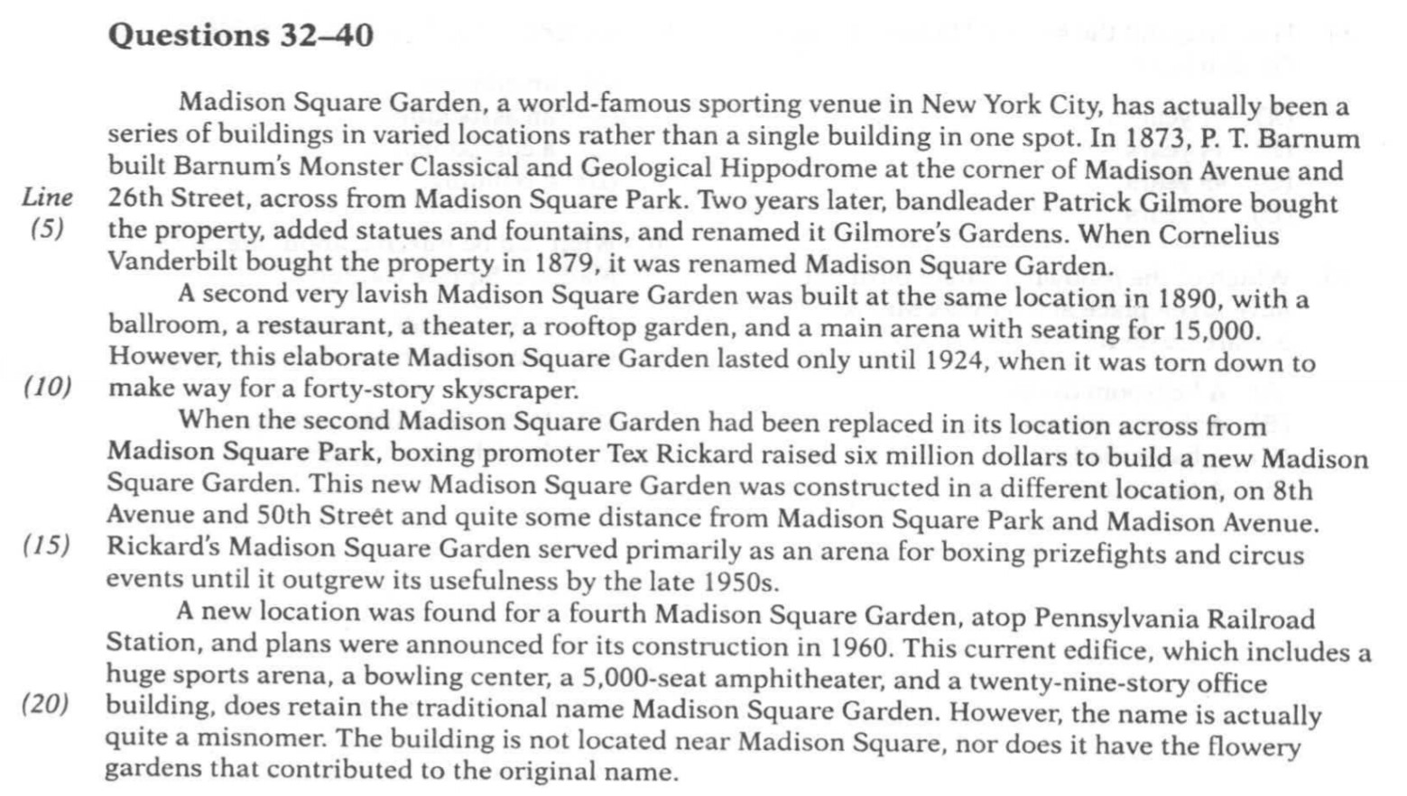

1. The main point of this passage is that Madison Square Garden
   1. has had a varied history in various locations
   2. was P.T. Barnum's major accomplishment
   3. is home to many different sporting events
   4. was named after an adjacent park
2. Which paragraph discusses the third incarnation of Madison Square Garden?
   1. The first paragraph
   2. The second paragraph
   3. The third paragraph
   4. The last paragraph
3. What is a "venue" in line 1?
   1. place where people come together
   2. An event in a competition
   3. An exhibit of various products
   4. An invitation to a program
4. According to the passage, Patrick Gilmore did all of the following EXCEPT that he
5. purchased the property at the corner of Madison Avenue and 26th Street
6. made improvements to the property that he bought
7. named the property that he bought Madison Square Garden
8. sold the property to Cornelius Vanderbilt
9. The word "lavish" in line 7 is closest in meaning to
   1. simple
   2. modern
   3. elaborate
   4. outlandish
10. How long did the second Madison Square Garden last?
    1. 11 years
    2. 34 years
    3. 45 years
    4. 60years
11. Which of the following would most likely have taken place at Rickard's Madison Square Garden?
    1. A ballroom dance
    2. A theater production
    3. A basketball game
    4. A tiger show
12. An "edifice" in line 18 is most likely
    1. an address
    2. an association
    3. a component
    4. a building

1. What can be inferred about the current Madison Square Garden?
   1. It is on Madison Avenue.
   2. It is across from Madison Square Park.
   3. It has incredible gardens.
   4. It is above a transportation center.

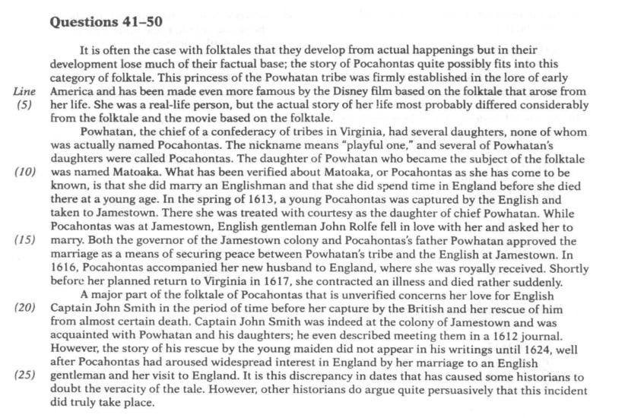

1. The main idea of the passage is that
   1. folktales are often not very factual
   2. Pocahontas did not really exist
   3. anyone of Powhatan's daughters could have been the Pocahontas of legend
   4. Pocahontas fell in love with John Smith and saved his life
2. The expression "arose from" in line 4 is closest in meaning to
   1. developed from
   2. went up with
   3. was told during
   4. climbed to
3. What is true about the name Pocahontas, according to the passage?
   1. It was the real name of a girl named Matoaka.
   2. It meant that someone was playful.
   3. Only one girl was known to have used this name.
   4. Powhatan was one of several people to given this nickname
4. How was Pocahontas treated when she was held at Jamestown?
   1. With respect
   2. With disdain
   3. With surprise
   4. With harshness
5. It can be inferred from the passage that Pocahontas
   1. never intended to return to Virginia
   2. had a long marriage
   3. suffered from a long illness
   4. did not mean to remain in England
6. The word "indeed" in line 21 is closest in meaning to
   1. therefore
   2. in fact
   3. unexpectedly
   4. in contrast
7. The pronoun "he" in line 22 refers to
   1. the governor
   2. Pocahontas
   3. John Smith
   4. Powhatan
8. When did John Smith most likely meet Pocahontas?
   1. In 1612
   2. In 1613
   3. In 1616
   4. In 1624
9. Why are some historians doubtful about the portion of the Pocahontas folktale dealing with John Smith?
   1. Captain John Smith probably never knew Pocahontas.
   2. Captain John Smith was never actually in Jamestown.
   3. His rescue purportedly happened while Pocahontas was in England.
   4. His account of the rescue did not appear until well after the event supposedly happened.
10. The word "veracity" in line 26 is closest in meaning to
    1. timing
    2. location
    3. understanding
    4. accuracy

**This is the end of Section 3.**

**If you finish in less than 55 minutes,**

**Check your work on Section 3 only.**

**Do NOT read or work on any other section of the test.**